|  |
| --- |
| *FlyAway*  ( Project Specification & Scrum Details) |

*Version History*

|  |  |
| --- | --- |
| Application Name | FlyAway |
| Developer Name | Hrishikesh Avhad |
| Purpose | Specifications & scrum details |
| Product Version | 1.0 |

# 

# 

# **Contents:**

# **1.Modules**

# **2.Sprint Details**

# **3.Project Github Link**

4. Cored Java Concepts Used

**5 .Tools and Technologies Used**

# 

1.Modules // x is just an ignorable warning.

A.Java Resources

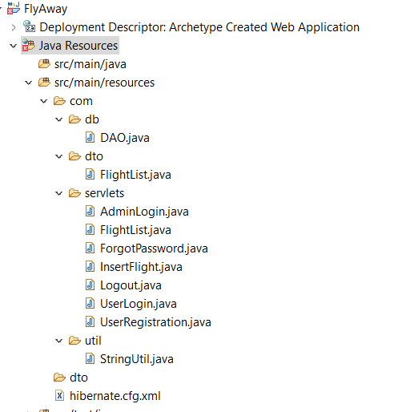

B. Javascript Resources/WebApp

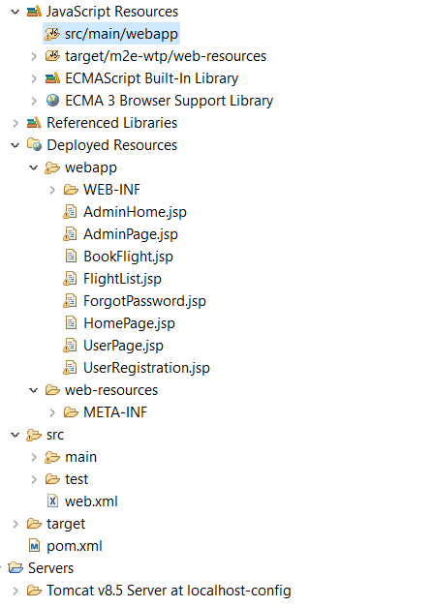

**2.Sprint wise work**

|  |  |
| --- | --- |
| **Sprint number** | **Modules** |
| 1 | Design homepage and travel details page. |
| 2 | Fetch available flights from database and redirect to user details page. |
| 3 | FlightList page with details of flight and form. |
| 4 | Admin Login page and page with all the flights data fetched from the database along with change password and InsertFlight facility for admin.  Testing. |

**3.Project Link**

|  |  |
| --- | --- |
| Repository Name | [Phase_2-FlyAway-](https://github.com/Rishikesh25/Phase_2-FlyAway-) |
| GitHub Link | https://github.com/Rishikesh25/Phase_2-FlyAway- |

# 

# **4.Core Java Concepts Used**

* Working with database (MySQL)
* Naming Standards
* Exceptions
* Modularity
* Object Oriented Programming
* Collections
* Control structures
* Data Structures
* Hibernate
* JSP (Java Server Pages)
* Servlet
* DAO and DTO Design Pattern

**5.Tools and Technologies Used**

* JSP, HTML, CSS, Bootstrap for **View**.
* JAVA Servlets as **Controller**
* MySQL database using Hibernate for **Model** to create tables for admin and flight details. Hosted on a remote server .
* Tomcat 8.5 as an Application Server.
* Eclipse: As an IDE to code for the application modularwise.
* Java: A programming language to develop the classes/servlets required for web pages, databases.
* Maven: To create a web-enabled Maven project and build deployable war file.
* Git: To connect and push files from the local system to GitHub
* GitHub: To store the application code and track its versions
* Scrum: An efficient agile framework to deliver the product incrementally